Semester 2 2020

ATAR course examinations 2020

Question/Answer booklet

**Year 11 ATAR COMPUTER SCIENCE AECSC**

Surname:

Other names:

WA student number (if known)

SIDE Teacher:

SIDE Student Coordinator:

**Supervisor’s declaration**

I declare that this examination paper has been completed by the student named above. The time and resource restrictions have been observed and the student has NOT accessed notes, texts, reference books, the internet, a computer, a calculator or a mobile phone unless otherwise specified. I understand that breaches of the examination rules could lead to an examination paper being cancelled or having an examination mark significantly lowered.

Supervisor’s name:

Signature: Date:

**Time allowed for this paper**

Reading time before commencing work: ten minutes

Working time: three hours

**Materials required/recommended for this paper**

***To be provided by the supervisor***

This Question/Answer booklet

Source booklet

***To be provided by the candidate***

Standard items: pens (blue/black preferred), pencils (including coloured), sharpener, correction fluid/tape, eraser, ruler, highlighters

Special items: up to three calculators, which do not have the capacity to create or store programs or text (any brands or models of these calculators are permitted)

**Important note to candidates**

No other items may be taken into the examination room. It is **your** responsibility to ensure that you do not have unauthorised material. If you have any unauthorised material with you, hand it to the supervisor **before** reading any further.

**Structure of this paper**

|  |  |  |  |  |  |
| --- | --- | --- | --- | --- | --- |
| Section | Number of questions available | Number of questions to be answered | Suggested working time (minutes) | Marks available | Percentage of examination |
| Section One:  Short answer | 20 | 20 | 70 | 124 | 40 |
| Section Two:  Extended answer | 5 | 5 | 110 | 103 | 60 |
|  |  |  |  | **Total** | 100 |

**Instructions to candidates**

1. The rules for the conduct of Western Australian external examinations are detailed in the *Year 12 Information Handbook 2020*. Sitting this examination implies that you agree to abide by these rules.

2. Write your answers in the spaces provided in this Question/Answer Booklet. A blue or black ballpoint or ink pen should be used. Wherever appropriate, fully labelled diagrams, tables and examples should be used to illustrate and support your answers.

3. You must be careful to confine your responses to the specific questions asked and to follow any instructions that are specific to a particular question. Where no specific instructions are given, you should feel free to use a range of formats to express your knowledge and understandings.

4. Spare pages are included at the end of this booklet. They can be used for planning your responses and/or as additional space if required to continue an answer.

* Planning: If you use the spare pages for planning, indicate this clearly at the top of the page.
  + Continuing an answer: If you need to use the space to continue an answer, indicate in the original answer space where the answer is continued, i.e. give the page number. Fill in the number of the question(s) that you are continuing to answer at the top of the page.

**Section 1: Short Answer (40%)**

This section contains **20** questions. You must answer **all** questions. Write your answers in the spaces provided.

Spare pages are included at the end of this booklet. They can be used for planning your responses and/or as additional space if required to continue to answer.

* Planning: If you use the spare pages for planning, indicate this clearly at the top of the page.
* Continuing an answer: If you need to use the space to continue an answer, indicate in the original answer space where the answer is continued, i.e. give the page number. Fill in the number of the question that you are continuing to answer at the top of the page.

Suggested working time: 70 minutes.

Questions 1 refers to information contained in the following scenario.

Melanie inputs a week’s worth of daily temperatures in degrees Fahrenheit as this is what her thermometer outputs. Each day of the week she writes down the daily temperature. At the end of the week she calculates the average daily temperature.

Unfortunately, the area manager requires the temperatures to be in Celsius. The formula to convert is (C is reading in Celsius and F is for reading in Fahrenheit)

**C = (F-32) x 5/9**

**Question 1 (10 marks)**

Complete the algorithm required to enter each daily temperate and total all the Fahrenheit readings. Find the average in Fahrenheit and then convert it to Celsius.

**Question 2 (4 marks)**

Explain the following programming terms.

Logic error:

Syntax error:

**Question 3 (4 marks)**

Complete the following table. The first one has been completed for you.

|  |  |
| --- | --- |
| **Binary** | **Decimal** |
| 01010000 | 80 |
| 01010010 |  |
|  | 71 |
| 11000010 |  |
|  | 45 |

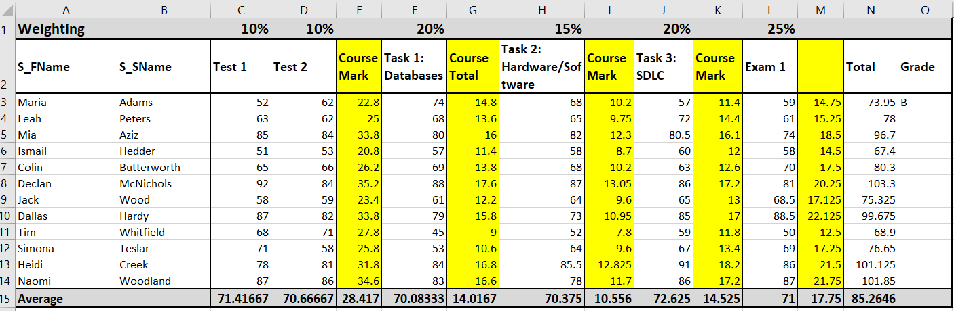Questions 4 refers to this spreadsheet data from Ms Gunther’s marksbook

**Question 4 (9 marks)**

1. Write the formula contained in Cell C15:___________________________________
2. Write the formula contained in Cell N15:____________________________________

1. Write the formula contained in Cell I3 that uses the % value in H1: _________________

d) **(4 marks)**

Using the following additional detail

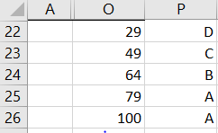

Write a VLookup to calculate the Grade to go in Column O of the Grade Column of Ms Gunthers’s

**Question 5 (8 marks)**

A program is required to read twenty numbers, add them together and then print their total. Discuss what is the most appropriate data control structure for this problem? (2 marks)

1. Create the pseudocode for this problem below. (6 marks)

**Question 6 (4 marks)**

Home routers typically integrate multiple networking devices into one unit.  
Discuss two functions a router can have within a home environment.

**Question 7 (3 marks)**

Discuss the differences between router and a switch.

**Question 8 (4 marks)**

Which of the following segments of code produce the output;

**2 4 6 8 10** ?

Explain your choice by discussing the output of all options.

|  |  |
| --- | --- |
| a) count = 2  repeat  count = count + 2  write(count)  until count = 10 | c) count = 2  repeat  write(count)  count = count + 2  until count = 10 |
| b) count = 2  repeat  write(count)  until count = 10 | d) count = 0  repeat  count = count + 2  write(count)  until count = 10 |

**Question 9 (1 mark)**

What sort of errors are identified in a trace table?

**Question 10 (15 marks)**

Complete a trace table for the following code for numbers 16, 40 and then 15, 41.

(!= is not equal to)

Begin

Num1 Input

Num2 Input

While Num1 != Num2

If Num1 > Num2 then

Num1 Num1-Num2

Else

Num2 Num2-Num1

End if

End while

Output Num1,Num2

End

|  |  |  |  |
| --- | --- | --- | --- |
| **Num1** | **Num2** | **Num1!=Num2** | **output** |
|  |  |  |  |
|  |  |  |  |
|  |  |  |  |
|  |  |  |  |
|  |  |  |  |
|  |  |  |  |
|  |  |  |  |
|  |  |  |  |
|  |  |  |  |
|  |  |  |  |
|  |  |  |  |
|  |  |  |  |
|  |  |  |  |
|  |  |  |  |

**Question 11 (4 marks)**

Referring to components within a CPU, discuss the fetch-execute cycle.

**Question 12 (5 marks)**

Complete the following table by identifying which protocol/standard best matches the description provided.

**TCP/IP**; **SMTP**; **HTTP**; **Wifi**; and **FTP**.

|  |  |
| --- | --- |
| **Protocol/Standard** | **Description of Purpose/Definition** |
|  | Its primary function is to establish a connection with the server and send HTML pages back to the user's browser. |
|  | Set of standards for implementing wireless local area network (WLAN) |
|  | Standard [network protocol](http://en.wikipedia.org/wiki/Network_protocol) used to copy a file from one host to another over a [TCP](http://en.wikipedia.org/wiki/Transmission_Control_Protocol)-based network |
|  | Basic Communication Protocol of the Internet. |
|  | An internet standard for electronic mail. |

**Question 13 (9 marks)**

Anthony is a medical specialist and has concerns that some of his sensitive electronic communication about his patients has been compromised.

1. Discuss the legal obligations to ensure the security of his data. (3 marks)

1. Discuss three (3) measures he can implement to secure the data on his network and when using the internet. (6 marks)

1:

2:

3:

**Question 14 (6 marks)**

Identify in which stage the following activities will occur in the System Development Life Cycle:

|  |  |
| --- | --- |
| **Activity** | **Stage** |
| Data Flow Diagrams |  |
| Hardware Purchase |  |
| Entity Relationship Diagrams |  |
| Software coding |  |
| Surveys |  |
| Feasibility Study |  |
| System Documentation |  |

**Question 15 (4 marks)**

Discuss two advantages and two disadvantages of a Standard Operating Environment.

**Question 16 (3 marks)**

Complete the following table identifying key features of software licensing types.

|  |  |
| --- | --- |
| **License Type** | **Features** |
| Freeware |  |
| Shareware |  |
| Open Source |  |

**Question 17 (7 marks)**

Draw an Entity Relationship Diagram (ERD) to represent the following scenario. Show Primary keys and Foreign keys.

Angelo visits a clinic and to see his Doctor at a scheduled appointment time. He has complex needs so will see his Doctor several times. (5 marks)

**Question 18 (3 marks)**

Identify the features of Ethernet and discuss the advantages and disadvantages of using this protocol for a communication medium.

**Question 19 (7 marks)**

(4 marks)

Identify the following CISCO icons. The first one has been done for you.

|  |  |
| --- | --- |
|  | Firewall |
|  |  |
|  |  |
|  |  |
|  |  |

(3 marks)

Using the above symbols complete the networking diagram below.

**Question 20 (8 marks)**

1. Identify the characteristics of data types in the table below. Provide an example to illustrate when they are used.

|  |  |  |
| --- | --- | --- |
| **Variable Data Type** | **Variable Data Characteristics** | **Example** |
| Real |  |  |
| Char |  |  |
| Boolean |  |  |
| Integer |  |  |

1. Discuss the difference between machine code and procedural programming languages. (2 marks)

End of section

**Section Two: Extended answer 60% (102 Marks)**

This section has **five (5)** questions. Answer **all** questions. Write your answers in the spaces provided.

Spare pages are included at the end of this booklet. They can be used for planning your responses and/or as additional space if required to continue to answer.

* Planning: If you use the spare pages for planning, indicate this clearly at the top of the page.
* Continuing an answer: If you need to use the space to continue an answer, indicate in the original answer space where the answer is continued, i.e. give the page number. Fill in the number of the question that you are continuing to answer at the top of the page.

Suggested working time: 110 minutes.

Trand Pty Ltd have decided to automate their Administration system.

Trant Pty Ltd manufactures widgets for the local and global markets. They have had recent and significant growth. The Trand Pty Ltd Administration department is struggling with the current paper filing system they use for managing personnel, payroll and training needs of the staff employed at the company.

A systems Analyst has observed the following about the Administration department’s data and information. Note that other departments at Trand Pty Ltd are external to the system.

* Each department emails Administration when they need staff. They will forward a Job Description and Administration will then place advertisements with various online employment agencies. The Job Description is filed with the advertisement in a pending folder.
* Potential employees apply by emailing their resume. Administration will vet the resume against the advertisement and the Job Description. Administration then forward approved resumes to the department asking for staff.
* Each department will conduct interviews themselves and advise Administration which candidates they may wish to interview. The administration team will then call previous employers of the candidate to check on their references. A record of the conversations is kept, and a copy sent to the Department.
* The department will advise Administration of their final selection and Administration will send out a Welcome Letter (to employee) that requests personal details such as Tax File Number and health issues. When received from the new employee these details are stored in the newly created employee file.
* Administration will then determine a start date, advise the relevant department and select a safety induction date. The new employee will then be advised of this safety induction date. Once the induction has been completed, a notification is put on the employees file and a copy sent to the department.
* At the end of each month, an invoice is received from the employment agencies. Administration ticks off the invoice against the number of advertisements and then approves for payment.

**Question 21 (17 Marks)**

Create a context diagram for Trand Pty Ltd’s Administration System.

**Question 22 (26 Marks)**

Create a Level 0 Data Flow Diagram for Trand Pty Ltd’s Administration System.

Following is an extract of the current spreadsheet that is used to keep track of employees, the department they work in and their payrates.

**Figure 1:Employee Details**

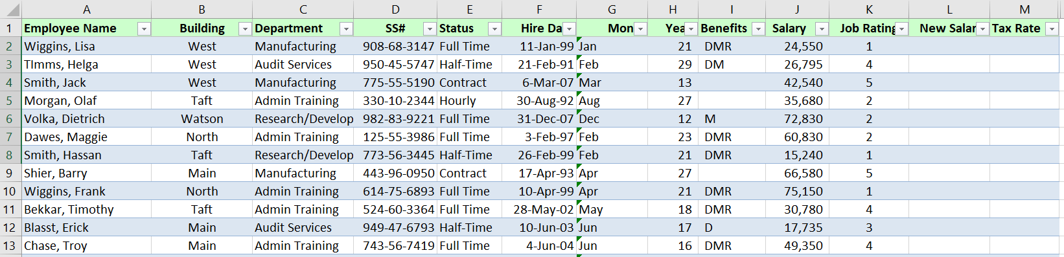

**Question 23 (24 Marks)**

The analyst has strongly recommended a Relational Database system be created to manage the Reception System.

1. Discuss why a Relational Database Management system would be recommend referring to specific examples within the data. (3 marks)

1. Create an Entity Relationship Diagram to represent the data shown in the spreadsheet on the previous page. Show Primary/Foreign keys and all attributes. (12 marks)

1. When the analyst was checking, it was found that Erick Blasst and Olaf Morgan worked in two departments.

Draw the new Entity Relationship Diagram to represent this change in business rules. Show only Primary and Foreign keys on the entities. (9 marks)

**Question 24 (26 Marks)**

1. Trand Pty Ltd have decided to award a pay rise to employees:

* 4.5% pay rise for manufacturing employees
* 4.0% pay rise for all other employees.

There are 100 employees in total.

Write the algorithm below required to implement this increase. You will use the variables Department, Salary, NewSalary, and Staffname. Your algorithm will output “Staffname, your new salary is NewSalary”. (12 marks)

**Figure 2: TaxTable**

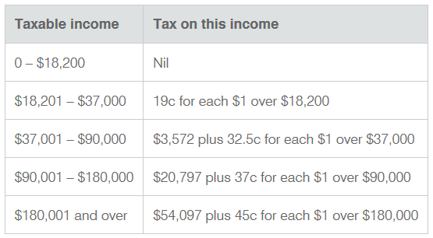

1. Write an algorithm that will calculate the tax payable for the NewSalary’s.

(See Figure 2)

Your algorithm will output the TaxRate and the TaxPayable on their NewSalary.

(14 marks)

**Question 25 (10 Marks)**

The Analyst has also recommended the following changes to occur

* A client server arrangement with the new server located in the Files office
* A combination of WiFi and wired Local Area Network to be located and accessible throughout the whole building.

1. Discuss the advantages and disadvantages of a client server arrangement for Trand Pty Ltd.Blue. (4 marks)

1. Identify and describe the software and devices necessary to establish and secure this network.

(6 marks)

End of questions